Multiple-Side Tangency
# Source: AI Source: Provided by: [Data Path: Persons Table -> ID Column: 1, Name_En Column: Motasem Essam] -> From: [ChatGPT] on [7/25/2026]
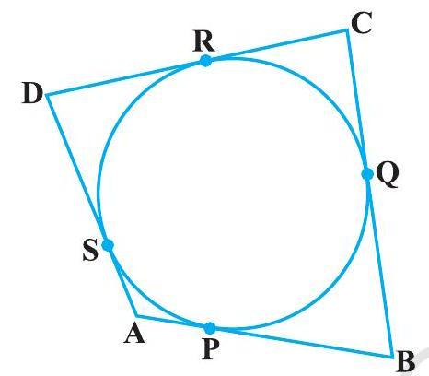
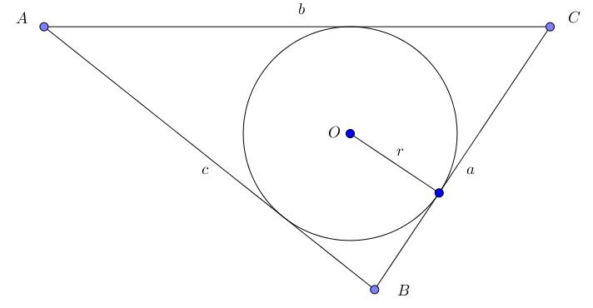
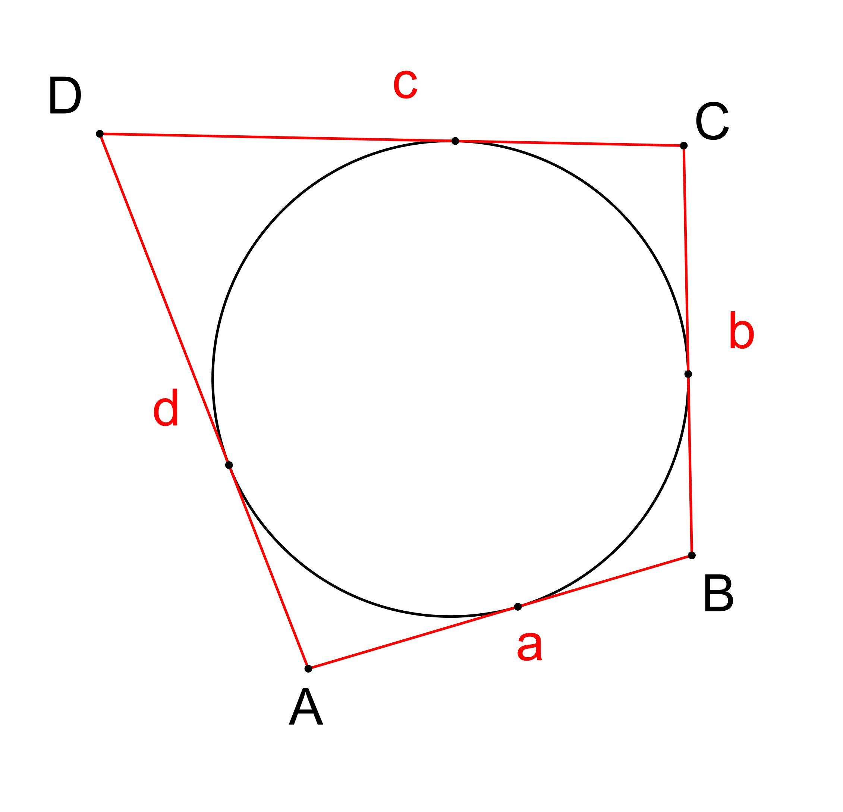
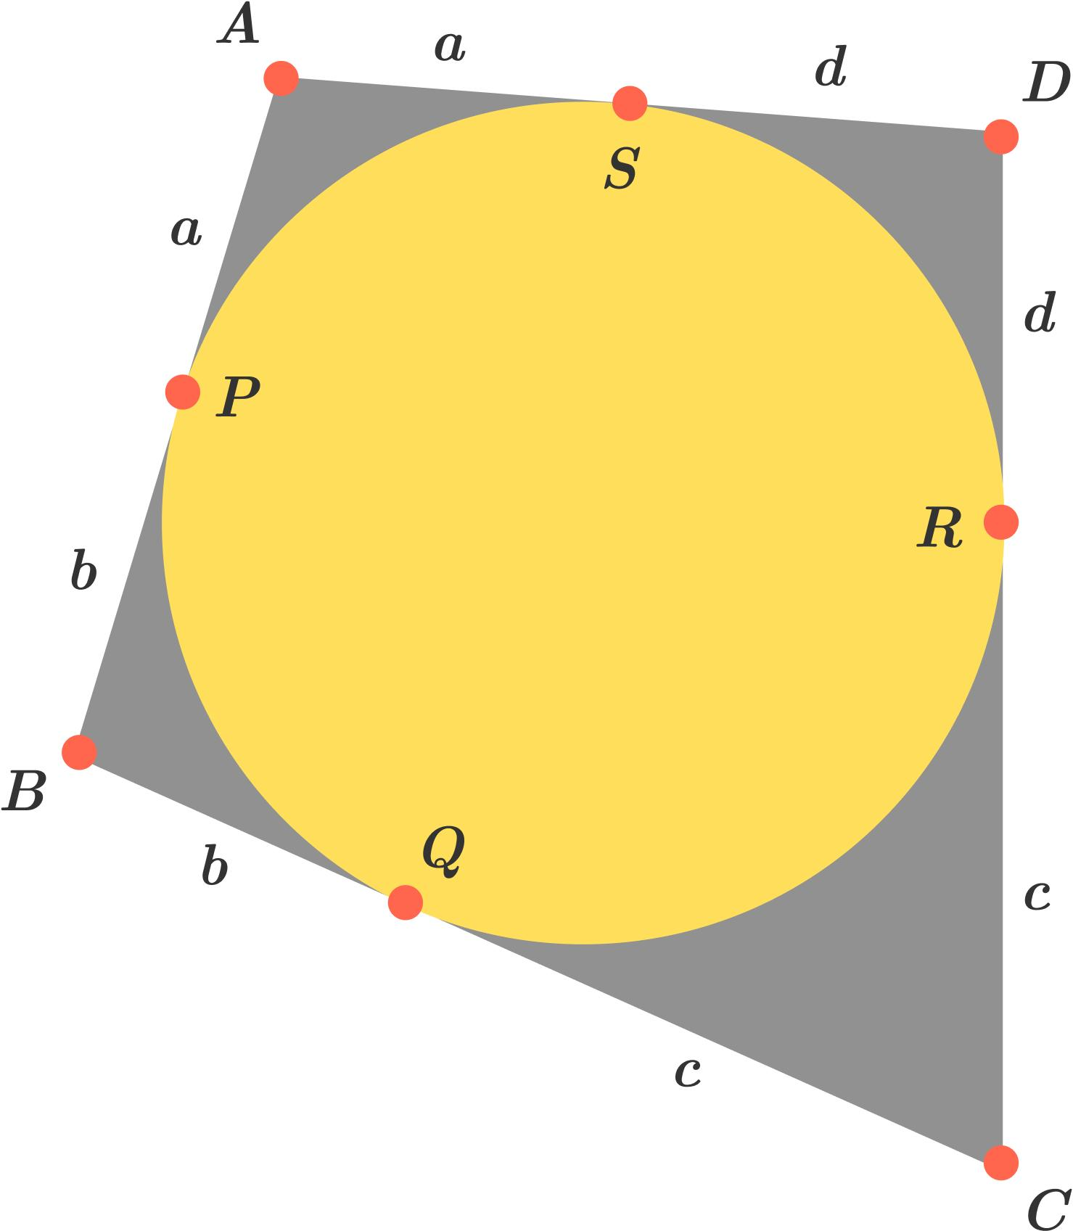
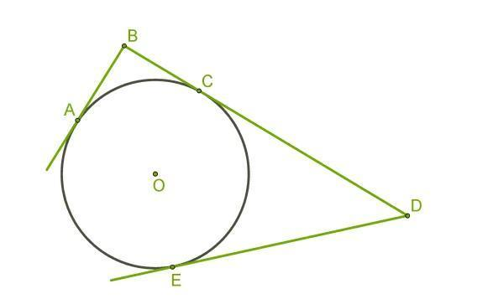

Definition
# Source: AI Source: Provided by: [Data Path: Persons Table -> ID Column: 1, Name_En Column: Motasem Essam] -> From: [ChatGPT] on [7/25/2026]
Multiple-Side Tangency is a type of Polygon–Circle Tangency in which a circle is tangent to two or more sides of a polygon.
Each tangent side touches the circle at its own point of tangency.
Thus, if a circle is tangent to $n$polygon sides, it has $n$corresponding tangency points, provided the contacts are distinct.

Fundamental Concept
# Source: AI Source: Provided by: [Data Path: Persons Table -> ID Column: 1, Name_En Column: Motasem Essam] -> From: [ChatGPT] on [7/25/2026]
Let a circle have center $O$and radius $r$, and suppose it is tangent to several sides of a polygon.
For every tangent side, the radius drawn from $O$to the corresponding point of tangency is perpendicular to that side.
For tangent sides $AB$, $BC$, and $CD$, for example:
$$\boxed{OT_{1}⊥AB} \\ \boxed{OT_{2}⊥BC} \\ \boxed{OT_{3}⊥CD}$$
Since all are radii:
$$\boxed{OT_{1}=OT_{2}=OT_{3}=r}$$
Therefore, the center of the circle is at the same perpendicular distance $r$from every tangent side.

Main Parts
# Source: AI Source: Provided by: [Data Path: Persons Table -> ID Column: 1, Name_En Column: Motasem Essam] -> From: [ChatGPT] on [7/25/2026]
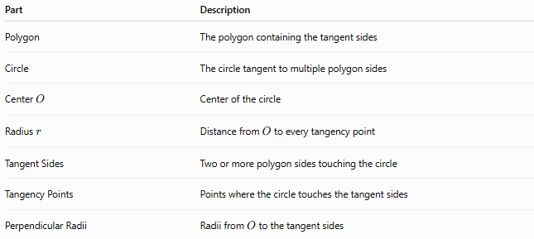
Part | Description
Polygon | The polygon containing the tangent sides
Circle | The circle tangent to multiple polygon sides
Center $O$ | Center of the circle
Radius $r$ | Distance from $O$to every tangency point
Tangent Sides | Two or more polygon sides touching the circle
Tangency Points | Points where the circle touches the tangent sides
Perpendicular Radii | Radii from $O$to the tangent sides

Defining Properties

1-At Least Two Tangent Sides
# Source: AI Source: Provided by: [Data Path: Persons Table -> ID Column: 1, Name_En Column: Motasem Essam] -> From: [ChatGPT] on [7/25/2026]
The defining condition is:
$$\boxed{\text{Number of tangent sides}≥2}$$
This distinguishes multiple-side tangency from single-side tangency.

2-One Tangency Point per Tangent Side
# Source: AI Source: Provided by: [Data Path: Persons Table -> ID Column: 1, Name_En Column: Motasem Essam] -> From: [ChatGPT] on [7/25/2026]
For distinct tangent sides, each side normally has its own point of tangency:
$$T_{1},T_{2},T_{3},…$$

3-Each Radius Is Perpendicular to Its Tangent Side
# Source: AI Source: Provided by: [Data Path: Persons Table -> ID Column: 1, Name_En Column: Motasem Essam] -> From: [ChatGPT] on [7/25/2026]
For every tangent side $l_{i}$:
$$\boxed{OT_{i}⊥l_{i}}$$

4-Equal Distances from the Center
# Source: AI Source: Provided by: [Data Path: Persons Table -> ID Column: 1, Name_En Column: Motasem Essam] -> From: [ChatGPT] on [7/25/2026]
Because all $OT_{i}$are radii:
$$\boxed{OT_{1}=OT_{2}=⋯=r}$$
Consequently, the center is equally distant from all tangent sides.

Basic Diagram
# Source: AI Source: Provided by: [Data Path: Persons Table -> ID Column: 1, Name_En Column: Motasem Essam] -> From: [ChatGPT] on [7/25/2026]
For example, a circle tangent to three sides:
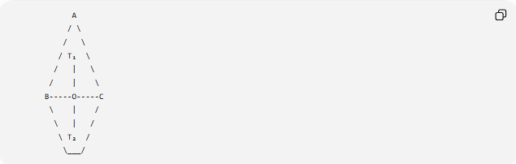
A
/ \
/ \
/ T₁ \
/ | \
/ | \
B-----O-----C
\ | /
\ | /
\ T₂ /
\___/
The exact appearance depends on the polygon, but the essential relationships are:
$$OT_{1}⊥\text{first tangent side} \\ OT_{2}⊥\text{second tangent side}$$
and:
$$OT_{1}=OT_{2}=r$$

Classification by Number of Tangent Sides
# Source: AI Source: Provided by: [Data Path: Persons Table -> ID Column: 1, Name_En Column: Motasem Essam] -> From: [ChatGPT] on [7/25/2026]
Multiple-side tangency can be classified according to how many polygon sides are tangent to the circle.
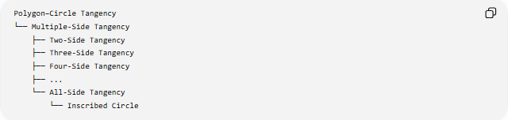
Polygon–Circle Tangency
└── Multiple-Side Tangency
├── Two-Side Tangency
├── Three-Side Tangency
├── Four-Side Tangency
├── ...
└── All-Side Tangency
└── Inscribed Circle
The maximum possible number of tangent sides is the number of sides of the polygon.
For an $n$-sided polygon:
$$\boxed{2≤k≤n}$$
where $k$is the number of tangent sides.

Two-Side Tangency
# Source: AI Source: Provided by: [Data Path: Persons Table -> ID Column: 1, Name_En Column: Motasem Essam] -> From: [ChatGPT] on [7/25/2026]
A circle has two-side tangency when it touches two sides of a polygon.
For example, the circle may touch two adjacent sides near a vertex.
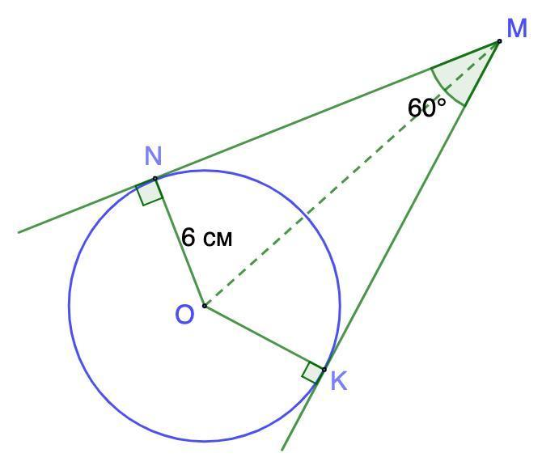
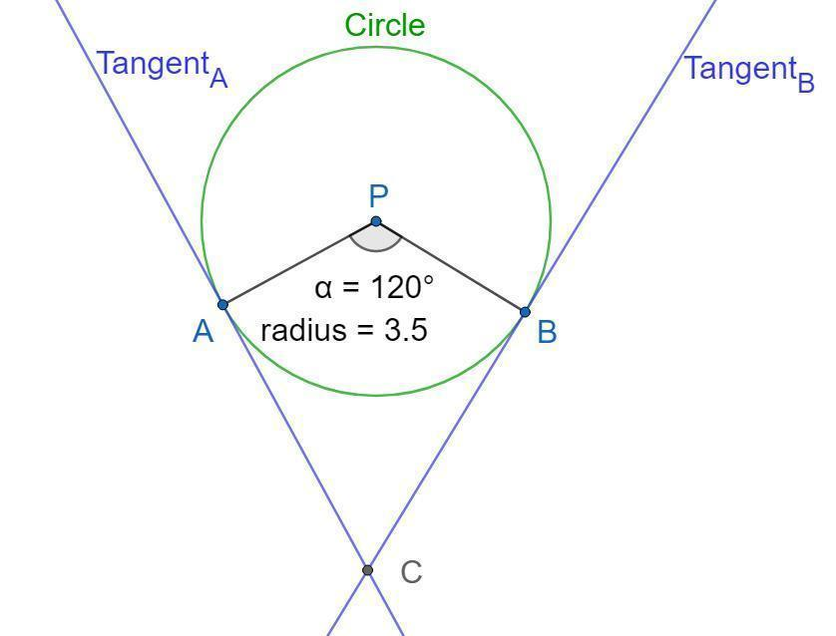
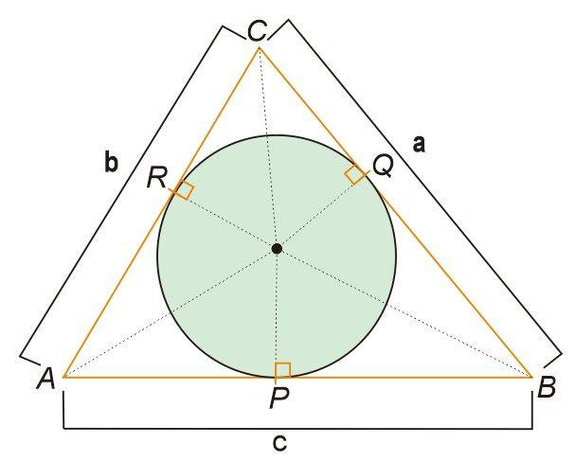
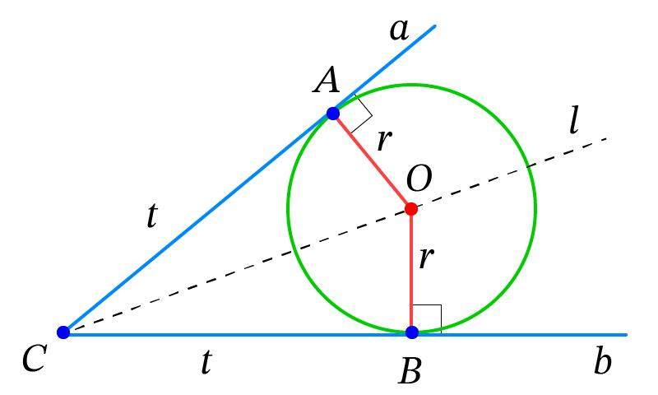
If the two sides form an angle with vertex $A$, the center of a circle tangent to both sides lies on an angle bisector.
If the angle is $θ$, and the circle has radius $r$, then the distance from the vertex to the center along the angle bisector is:
$$\boxed{AO=\frac{r}{sin⁡\left(θ/2\right)}}$$
This follows because the perpendicular distance from $O$to either side is $r$.

Three-Side Tangency
# Source: AI Source: Provided by: [Data Path: Persons Table -> ID Column: 1, Name_En Column: Motasem Essam] -> From: [ChatGPT] on [7/25/2026]
A circle has three-side tangency when it touches three sides of a polygon.
A particularly important example occurs in a triangle.
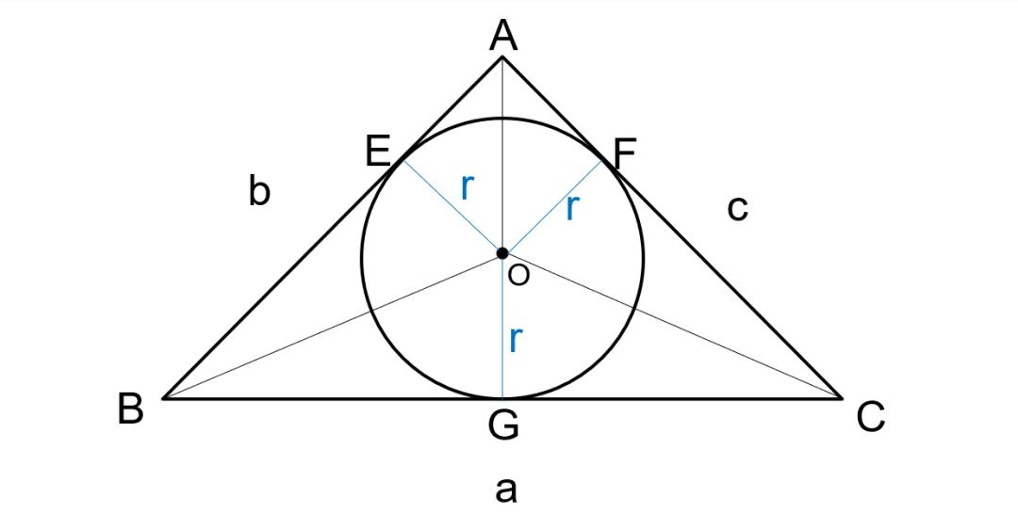
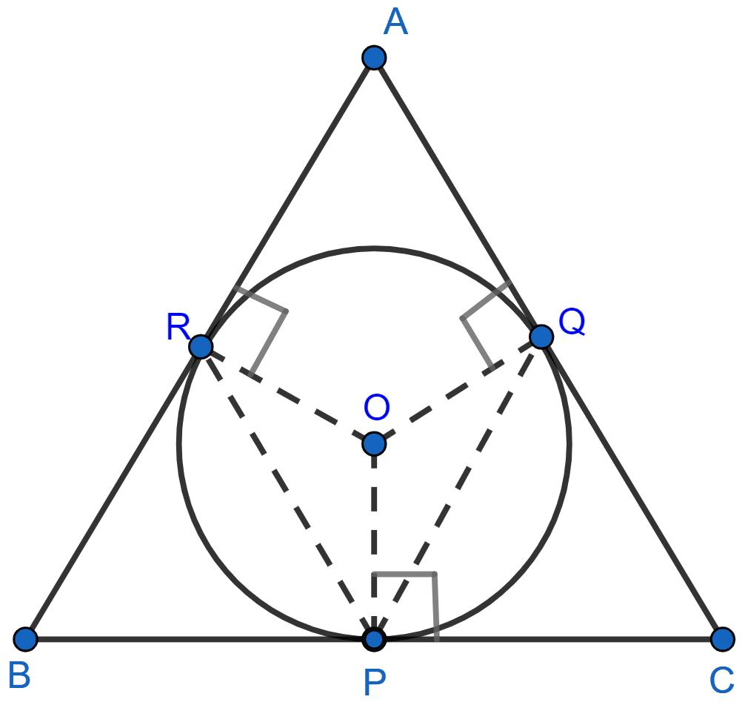
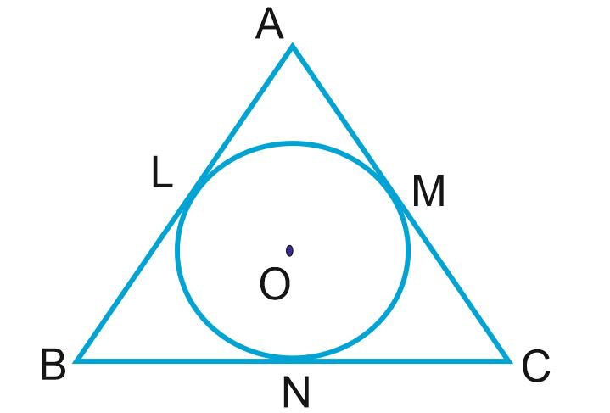
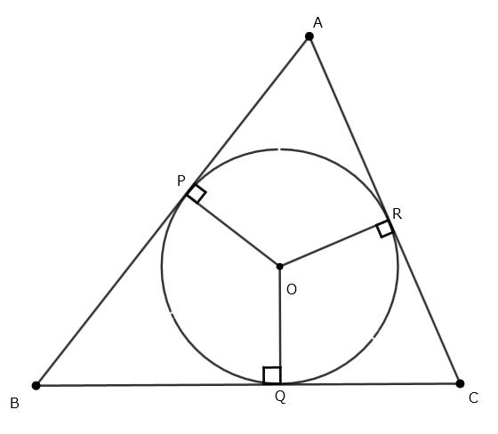
When a circle inside a triangle is tangent to all three sides, it is the incircle.
Its center is the incenter.
The three radii drawn to the tangency points are perpendicular to the three sides.

Four-Side Tangency
# Source: AI Source: Provided by: [Data Path: Persons Table -> ID Column: 1, Name_En Column: Motasem Essam] -> From: [ChatGPT] on [7/25/2026]
A circle may be tangent to four sides of a quadrilateral.
If it is tangent to all four sides, the quadrilateral is called a tangential quadrilateral, and the circle is an inscribed circle of that quadrilateral.
A necessary and sufficient condition for a convex quadrilateral to have an incircle is:
$$\boxed{AB+CD=BC+DA}$$
This is known as Pitot's theorem for tangential quadrilaterals.

All-Side Tangency
# Source: AI Source: Provided by: [Data Path: Persons Table -> ID Column: 1, Name_En Column: Motasem Essam] -> From: [ChatGPT] on [7/25/2026]
The most complete form of multiple-side tangency occurs when the circle touches every side of the polygon.
This is called an inscribed circle or incircle of the polygon.
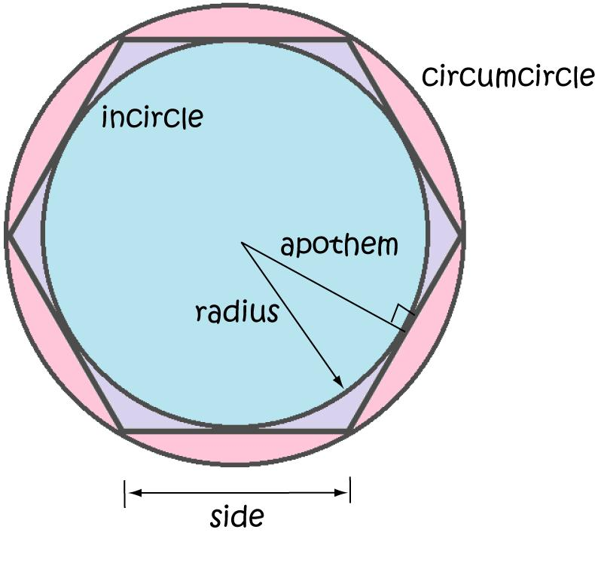
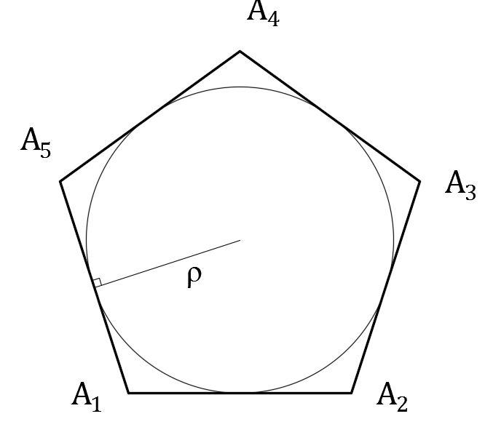
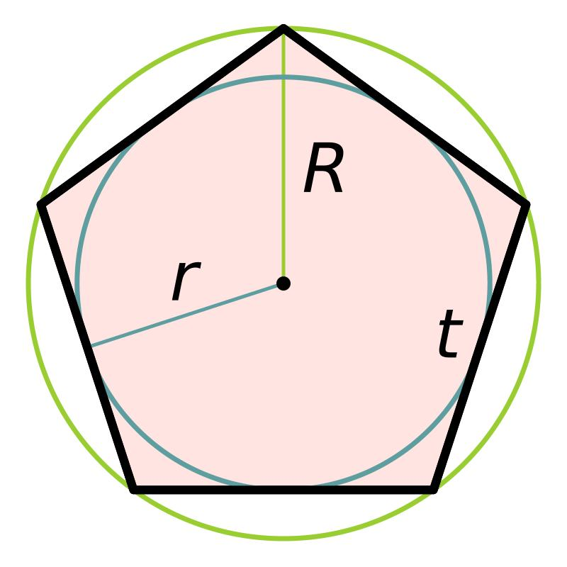
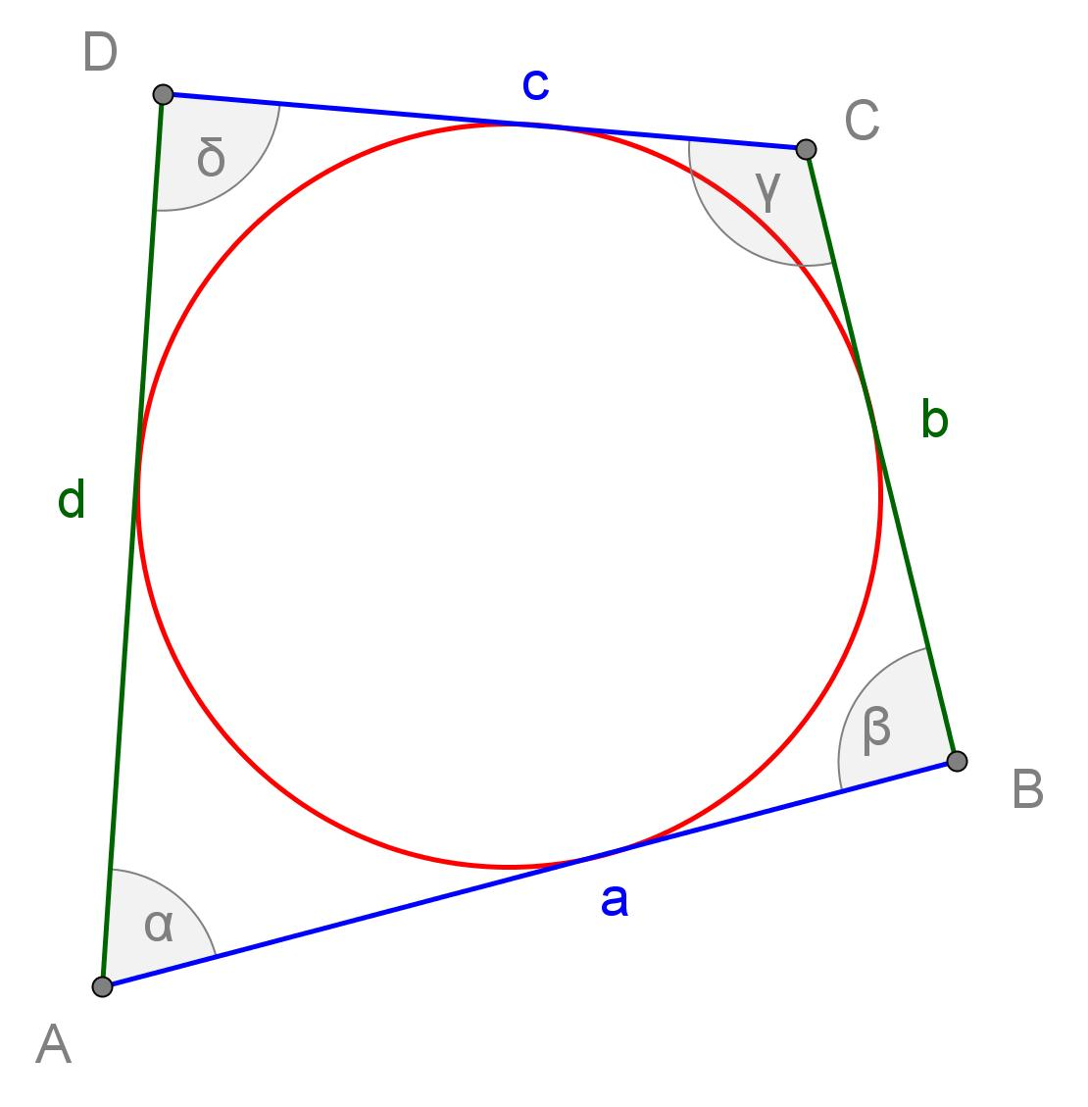
If an $n$-sided polygon has a circle tangent to all its sides, the polygon is called a:
$$\boxed{\text{Tangential Polygon}}$$
The circle is an:
$$\boxed{\text{Inscribed Circle}}$$

Multiple-Side Tangency and Angle Bisectors
# Source: AI Source: Provided by: [Data Path: Persons Table -> ID Column: 1, Name_En Column: Motasem Essam] -> From: [ChatGPT] on [7/25/2026]
When a circle is tangent to two sides that meet at a vertex, its center must be equidistant from those two sides.
The locus of points equidistant from two intersecting lines is their angle bisector.
Therefore:
$$\boxed{\text{Center lies on the angle bisector}}$$
For a circle tangent to several sides, the center must simultaneously satisfy the corresponding equal-distance conditions.
This explains why the incenter of a triangle is the intersection of its three internal angle bisectors.

Tangency Points and Equal Tangent Segments
# Source: AI Source: Provided by: [Data Path: Persons Table -> ID Column: 1, Name_En Column: Motasem Essam] -> From: [ChatGPT] on [7/25/2026]
If two tangent sides meet at a vertex $A$, and the circle touches them at $T_{1}$and $T_{2}$, then the tangent segments from $A$are equal:
$$\boxed{AT_{1}=AT_{2}}$$
This follows from the theorem that tangent segments drawn from the same external point to a circle are equal.
For a polygon with several tangent sides, this creates useful relationships between portions of the polygon's sides.

Center-to-Side Distance
# Source: AI Source: Provided by: [Data Path: Persons Table -> ID Column: 1, Name_En Column: Motasem Essam] -> From: [ChatGPT] on [7/25/2026]
For every tangent side:
$$\boxed{d\left(O , l_{i}\right)=r}$$
where $l_{i}$is the tangent side.
Thus, for $k$tangent sides:
$$\boxed{d\left(O , l_{1}\right)=d\left(O , l_{2}\right)=⋯=d\left(O , l_{k}\right)=r}$$
This is one of the most important characteristics of multiple-side tangency.

Multiple-Side Tangency vs Single-Side Tangency
# Source: AI Source: Provided by: [Data Path: Persons Table -> ID Column: 1, Name_En Column: Motasem Essam] -> From: [ChatGPT] on [7/25/2026]
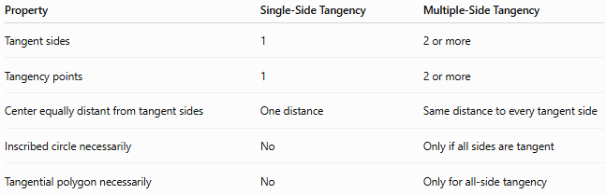
Property | Single-Side Tangency | Multiple-Side Tangency
Tangent sides | 1 | 2 or more
Tangency points | 1 | 2 or more
Center equally distant from tangent sides | One distance | Same distance to every tangent side
Inscribed circle necessarily | No | Only if all sides are tangent
Tangential polygon necessarily | No | Only for all-side tangency

Multiple-Side Tangency vs Inscribed Circle
# Source: AI Source: Provided by: [Data Path: Persons Table -> ID Column: 1, Name_En Column: Motasem Essam] -> From: [ChatGPT] on [7/25/2026]
An important taxonomy distinction is:
Every inscribed circle is a multiple-side tangent circle, but not every multiple-side tangent circle is an inscribed circle.
For example, a circle touching only two sides of a pentagon has multiple-side tangency, but it is not an inscribed circle because it does not touch all five sides.
Therefore:
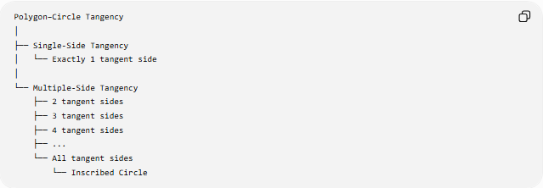
Polygon–Circle Tangency
│
├── Single-Side Tangency
│ └── Exactly 1 tangent side
│
└── Multiple-Side Tangency
├── 2 tangent sides
├── 3 tangent sides
├── 4 tangent sides
├── ...
└── All tangent sides
└── Inscribed Circle

Special Case: Regular Polygons
# Source: AI Source: Provided by: [Data Path: Persons Table -> ID Column: 1, Name_En Column: Motasem Essam] -> From: [ChatGPT] on [7/25/2026]
Every regular polygon has an inscribed circle.
For a regular $n$-gon:
$$\boxed{r=a\frac{1}{2tan⁡\left({180}^{∘}/n\right)}}$$
where:
- $a$= side length
- $r$= inradius
The inradius is also the apothem:
$$\boxed{r=\text{apothem}}$$
The area is:
$$\boxed{A=\frac{1}{2}Pr}$$
where $P$is the perimeter.

Example
# Source: AI Source: Provided by: [Data Path: Persons Table -> ID Column: 1, Name_En Column: Motasem Essam] -> From: [ChatGPT] on [7/25/2026]
Suppose a circle of radius:
$$r=4\text{ cm}$$
is tangent to three sides of a polygon.
Then the perpendicular distance from its center $O$to each of those three sides is:
$$OT_{1}=OT_{2}=OT_{3}=4\text{ cm}$$
Therefore:
$$\boxed{d\left(O , l_{1}\right)=d\left(O , l_{2}\right)=d\left(O , l_{3}\right)=4\text{ cm}}$$
If these are the only three tangent sides, the circle has three-side tangency, not full polygon tangency.

Important Special Cases

Two Tangent Sides
# Source: AI Source: Provided by: [Data Path: Persons Table -> ID Column: 1, Name_En Column: Motasem Essam] -> From: [ChatGPT] on [7/25/2026]
The circle touches two sides.
$$\boxed{k=2}$$

Three Tangent Sides
# Source: AI Source: Provided by: [Data Path: Persons Table -> ID Column: 1, Name_En Column: Motasem Essam] -> From: [ChatGPT] on [7/25/2026]
The circle touches three sides.
$$\boxed{k=3}$$
A triangle with all three sides tangent to the circle has an incircle.

All Tangent Sides
# Source: AI Source: Provided by: [Data Path: Persons Table -> ID Column: 1, Name_En Column: Motasem Essam] -> From: [ChatGPT] on [7/25/2026]
For an $n$-sided polygon:
$$\boxed{k=n}$$
The circle is tangent to every side and is an inscribed circle.

Applications
# Source: AI Source: Provided by: [Data Path: Persons Table -> ID Column: 1, Name_En Column: Motasem Essam] -> From: [ChatGPT] on [7/25/2026]
Multiple-side tangency is important in:
- Geometric constructions
- Triangle and polygon geometry
- CAD and technical drawing
- Computer graphics
- Mechanical design
- Architecture
- Packaging design
- Collision and contact detection
- Optimization problems
- Tangential polygon construction

Key Points
# Source: AI Source: Provided by: [Data Path: Persons Table -> ID Column: 1, Name_En Column: Motasem Essam] -> From: [ChatGPT] on [7/25/2026]
- Multiple-Side Tangency occurs when a circle touches two or more polygon sides.
- Every tangent side has a corresponding point of tangency.
- The radius to each tangency point is perpendicular to its tangent side:
$$\boxed{OT_{i}⊥l_{i}}$$
- The center has the same perpendicular distance from every tangent side:
$$\boxed{d\left(O , l_{1}\right)=d\left(O , l_{2}\right)=⋯=r}$$
- Two tangent sides meeting at a vertex imply that the circle's center lies on the corresponding angle bisector.
- Tangent segments from the same polygon vertex are equal.
- When every side is tangent to the circle, the circle is an inscribed circle and the polygon is a tangential polygon.
- Therefore, all-side tangency is a special case of multiple-side tangency.

Conclusion
# Source: AI Source: Provided by: [Data Path: Persons Table -> ID Column: 1, Name_En Column: Motasem Essam] -> From: [ChatGPT] on [7/25/2026]
Multiple-Side Tangency describes a polygon–circle configuration in which a circle is tangent to two or more sides of a polygon.
Its fundamental property is:
$$\boxed{d\left(O , l_{1}\right)=d\left(O , l_{2}\right)=⋯=d\left(O , l_{k}\right)=r}$$
where $k≥2$.
The classification can be summarized as:
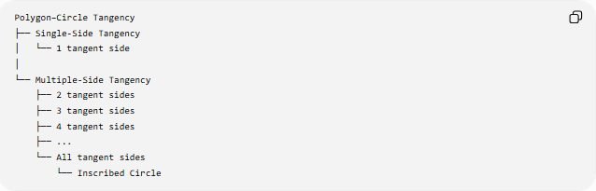
Polygon–Circle Tangency
├── Single-Side Tangency
│ └── 1 tangent side
│
└── Multiple-Side Tangency
├── 2 tangent sides
├── 3 tangent sides
├── 4 tangent sides
├── ...
└── All tangent sides
└── Inscribed Circle
Thus, Multiple-Side Tangency is the broader category, while an Inscribed Circle represents its special case where the circle touches every side of the polygon.

